**Reporting Employees**

**DESCRIPTION**

Your task is to print the **employeeid** and the employeeid of the employee which this employee reports to if and only if the employee is not a manager.

Print the result in the **increasing order** of employeeid.

The title may have some **capital letters**, for example General Manager, adjust your logic accordingly.

Database: **DoSelect**

**Employee**

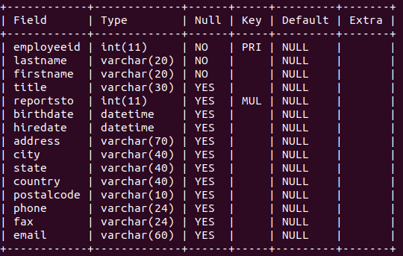

**Customer**

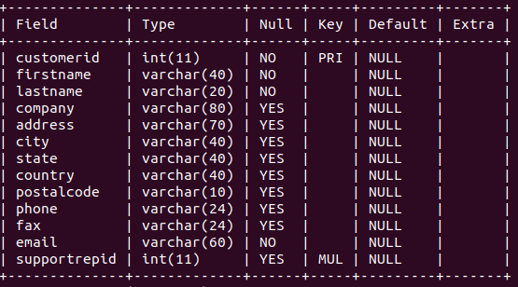

**Database Relationships**

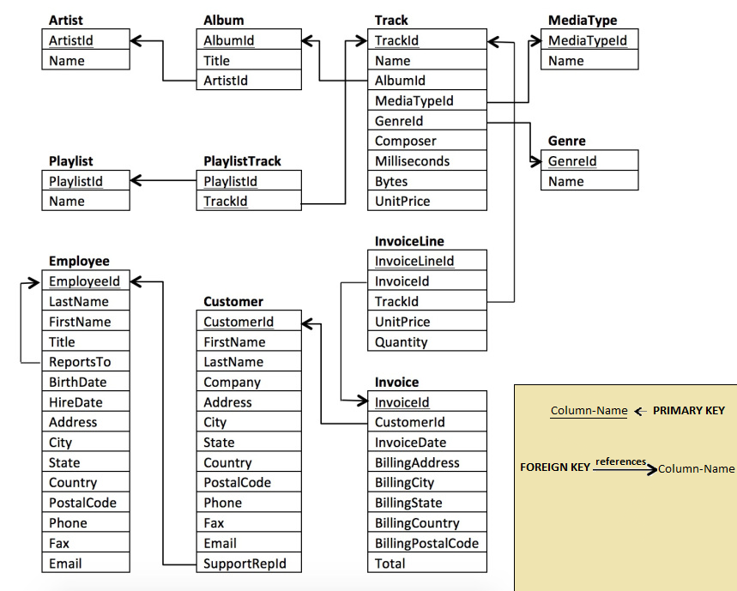

**Note:**

* You can run multiple queries at once and see their output in the output section in the order the queries were written.
* Do not forget to **end** your query by a semicolon.

Solution:

alter session set current_schema = doselect;

SET heading OFF

/*

* Enter your query below.

* Please append a semicolon ";" at the end of the query

*/

-- use doselect;

select employeeid,reportsto from Employee where title!='General Manager' and title!='Sales Manager' and title!='IT Manager';

**Nancy Edwards**

**DESCRIPTION**

Your Task is to print the employee ids of the employees that do not report to **Nancy Edwards**(There is a space in between first name and last name).

The columns and the column names must strictly follow the following order**:**

1. **employeeid**

**Note:**

* **Print the result in the increasing order of employeeid**.
* You **should not**include the employee id of **Nancy Edwards**.

**Database : DoSelect**



**Note:**

* Make sure **use doselect** is present in the query before you submit as your output is compared with the expected output without the column names.

Solution:

alter session set current_schema = doselect;

SET heading OFF

-- Write your sql queries here

select employeeid from employee

where reportsto is null or

reportsto != (select employeeid from employee

where firstname='Nancy' and lastname='Edwards')

and firstname !='Nancy'and lastname!='Edwards'

order by employeeid;

**Track And Genre**

**DESCRIPTION**

Your Task is to print the following:

* For each track and a genre, print 1 if the track belongs to that genre, or print 0 otherwise.

The columns must strictly follow the following order**:**

* **trackid**
* **genreid**
* **included**

**Note:**

* You have to print the results in the increasing order of **trackid**. For two records of the same trackid, break the tie by the increasing order of **genreid.**

**Database : DoSelect**



**Note:**

* Make sure **use doselect** is present in the query before you submit as your output is compared with the expected output without the column names.

Solution:

alter session set current_schema = doselect;

SET heading OFF

select trackid,track.genreid,case

when track.genreid = (select genreid

from genre

where name=track.name) then 1

else 0

end as included

from track inner join genre

on track.genreid=genre.genreid

order by trackid,track.genreid;